Title: We Are Chosen Vessels to Bear His Name

Text: Psalm 124[1]

Never should feel ARRIVED and not needing HELP.

There is a balance with a measure of Joy, peace a companion need for MORE of Jesus.

He is God and He can do the impossible.

The Lord’s ways are diverse! We can not ‘figure’ God out and put Him in a box.

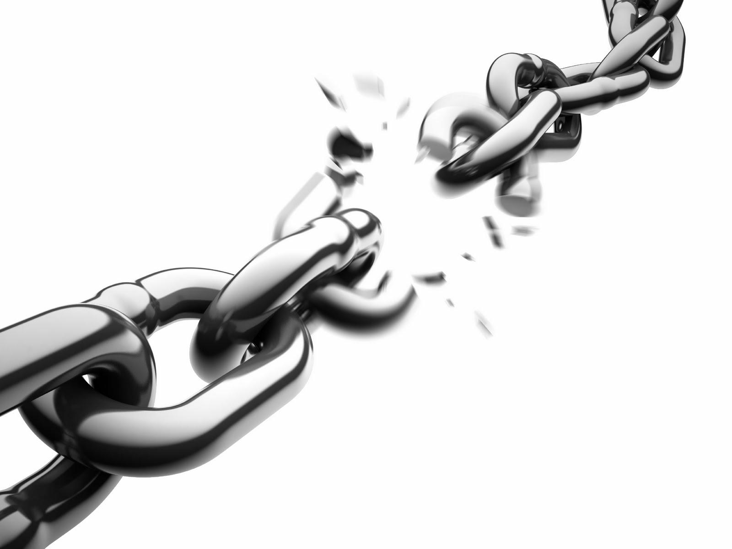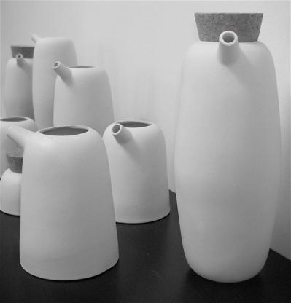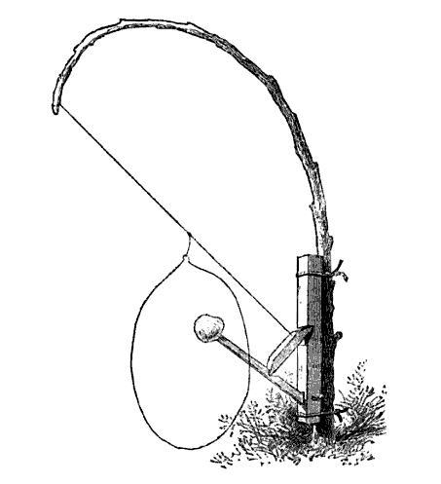

Many people are taken by broken snares and are bound by broken chains.

There is a promise and provision to walk out free. You don’t have to be BOUND.

Our victory is in the name of the Lord! Jesus said, “I am come to destroy the works of the devil.”

Psalm 116:3 The sorrows of death compassed me, and the pains of hell gat hold upon me: I found trouble and sorrow.

1. "Treasury of David—Psalm 124." 2004. 17 May. 2012 <<http://www.spurgeon.org/treasury/ps124.htm>>